Det blev observeret, at vi har 180 grader faseskift mellem de to antenner:
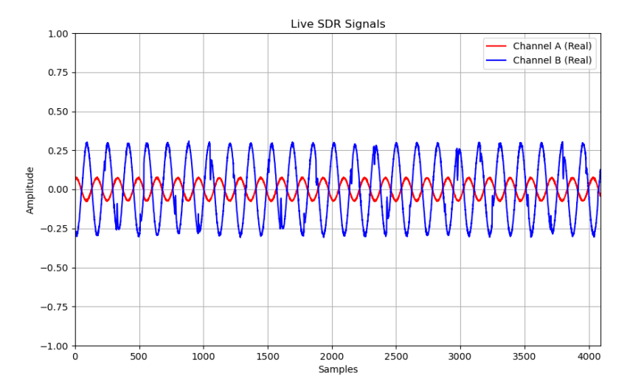

Når de sidder med feedline væk fra hinanden

Vendt 1 antenne:
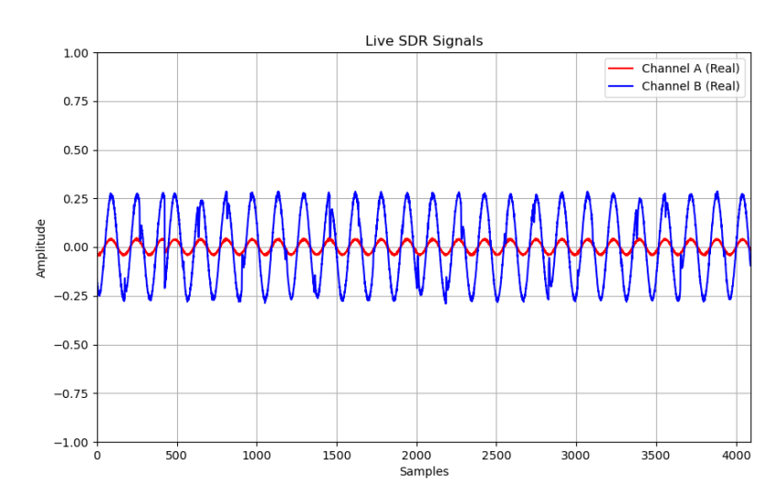

Med fælles groundplane
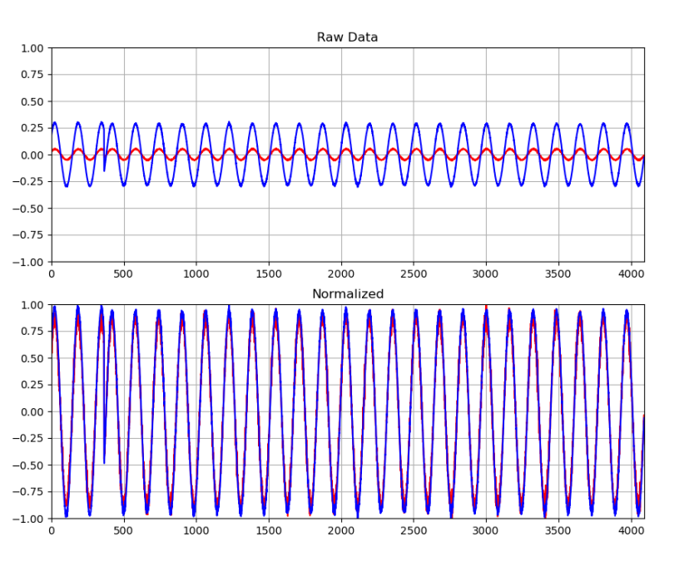
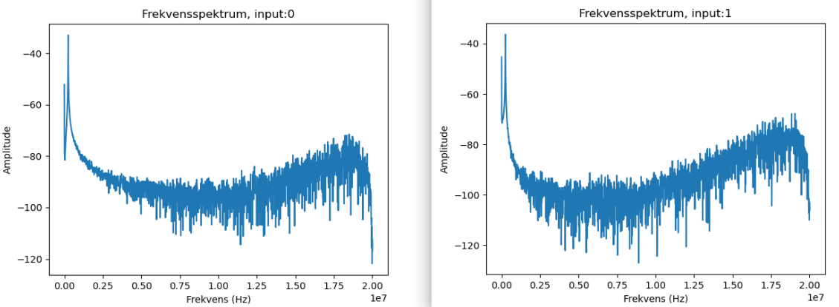
En smule bedre SNR

Afkoblingsplade i midten (Lang i.e. 5 cm ud):
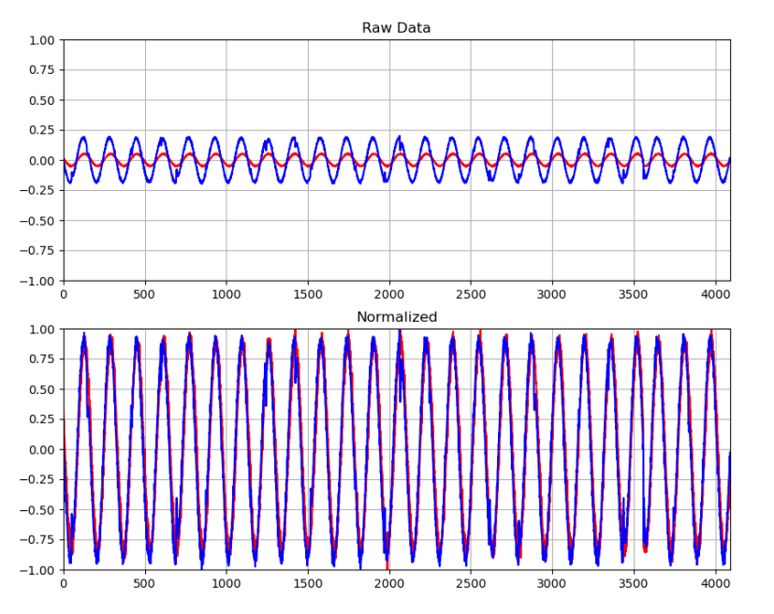
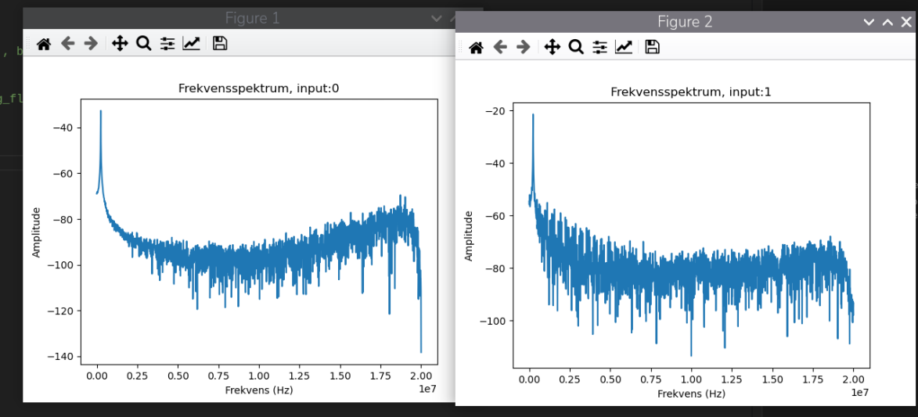

BF still fucked
Afkoblingsplade kort (2 mm):
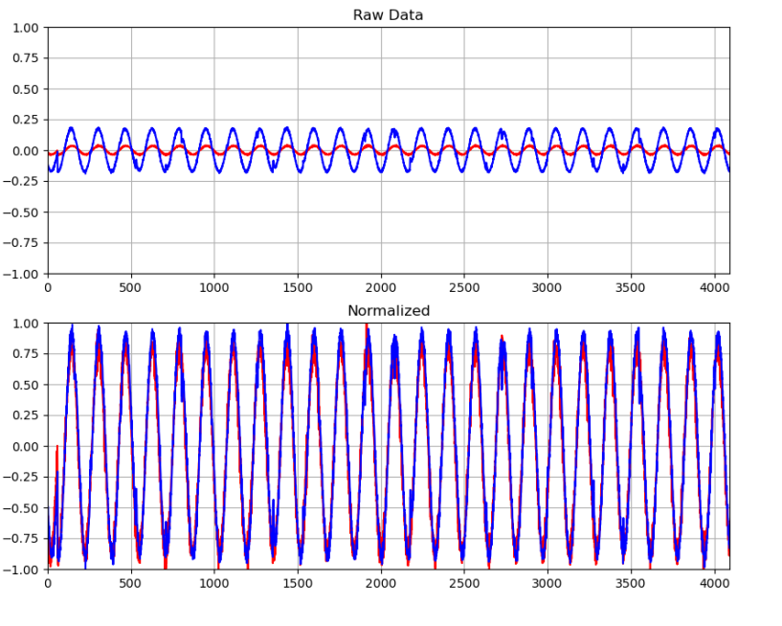
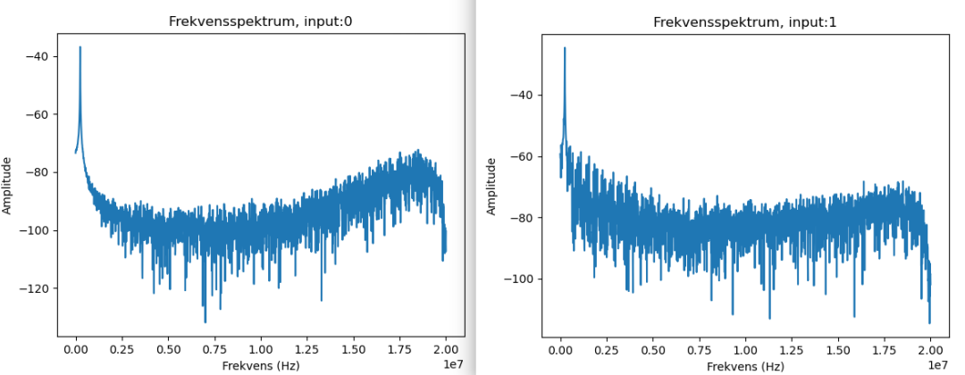

SDR introducere et 180 graders faseskift på den ene kanal. Ingen ide om hvorfor
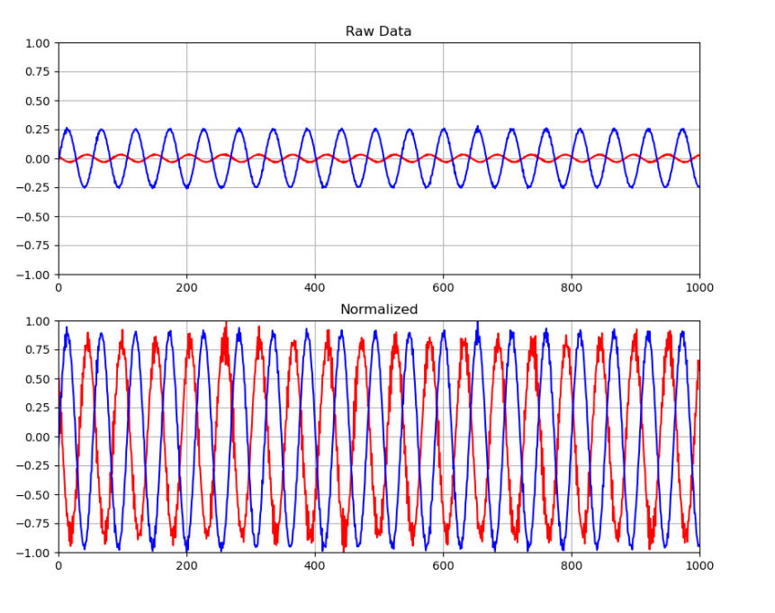
Ift. normalisering af dataet, skal DET IKKE GØRES!!!!!
Det fucker dataet op.

Vi overflower data:
Med 900 samples:
bf: 54.121752568178636
bf: 56.6411643254335
bf: 57.11084651728373
bf: 54.397633855624655
bf: 55.38259845212611
bf: 50.7450568102651
bf: 49.79657238400446
bf: 49.493330968877856
bf: 55.090757090199745
bf: 48.67708715974008
bf: 52.62150556702596
bf: 64.89024282113317
bf: -79.50967104513155
bf: -69.76490556955932
bf: -51.169138789314346
bf: -71.5592739432784
bf: 40.23648777027627
bf: 38.26883858791339
bf: 40.37328840867922

Med 100 samples:
bf: 58.79577438028044
bf: 63.93719837359241
bf: 59.502577678695815
bf: 62.10862984027258
bf: 55.35067830316541
bf: 60.28006130695277
bf: 59.08989575284684
bf: 58.09353110314515
bf: 60.42142196663583
bf: 62.97047386221134
bf: 63.25547519221757
bf: 59.954019785425665
bf: 59.84685928534333
bf: 57.95673046474217
bf: 58.9280149974033

TEST 2:
Vendt antenne tilbage til udgangspunkt
Intet groundplane
Ingen barrier
Reduceret samplemængde til 100
Ingen normalisering af dataet

Ved cirka +5 grader, har vi dette:
bf: -7.249293830037876
bf: -3.3846757951537136
bf: -1.8912688259211963
bf: 3.060914284266656
bf: 13.450922770972928
bf: -3.3481956249129237
bf: -4.492760966217842
bf: -6.380609776178965
bf: 1.182185516865737
bf: 9.82114583201388
bf: -0.9541844528607812
bf: -7.3610143514003035
bf: -2.2355504325686932
bf: -1.6153875384751895
bf: 3.5328764867569302
bf: 13.286762004889347
bf: -0.06726031388147458
bf: -1.1092251763841572
bf: -4.955603126147926
bf: 0.017100079800366267
bf: -5.347764956236461
bf: -1.9163489429617375
bf: -5.03312348790962
bf: -1.6039874852749412
bf: -2.176270155927394
bf: 3.2820753163514778
bf: 6.624570914664258
bf: -0.5483425589319401
bf: -1.7704282619985654
bf: -4.793722370704403
bf: 0.9587444741408704
bf: -19.08938908381573
bf: -1.0066246975819213
bf: -2.2309904112885914

Ved -18:
bf: 33.98925861654021
bf: 28.134191292892687
bf: 23.911611587520735
bf: 38.74080079040368
bf: 60.44878209431642
bf: 34.15569939326384
bf: 28.038430846010613
bf: 28.40779256969865
bf: 32.47077153026713
bf: 38.41247925823652
bf: 56.30144274006611
bf: 33.48081624380913
bf: 28.115951207772305
bf: 24.201172938807048
bf: 43.30310208114303
bf: 49.07380901110871
bf: 33.024814115799195
bf: 28.494432974020548
bf: 27.47982823919845
bf: 32.76489290283355

Ved +20:

bf: -9.374263746564159
bf: -13.013160728083399
bf: -10.29082802386411
bf: -14.857689335883572
bf: -10.277147960023816
bf: -12.495598312792131
bf: -7.819296490050285
bf: -10.382028449466096
bf: -13.852204643621679
bf: -9.032262150556706
bf: -15.45505212357658
bf: -11.455913460929493
bf: -28.770314261466556
bf: -11.435393365169041
bf: -14.43588736747438
bf: -11.081991715961339
bf: -13.102081143045341
bf: -8.979821905835566
bf: -23.35072897006853
bf: -11.20283227988397
bf: -7.130733276755291

Støj:
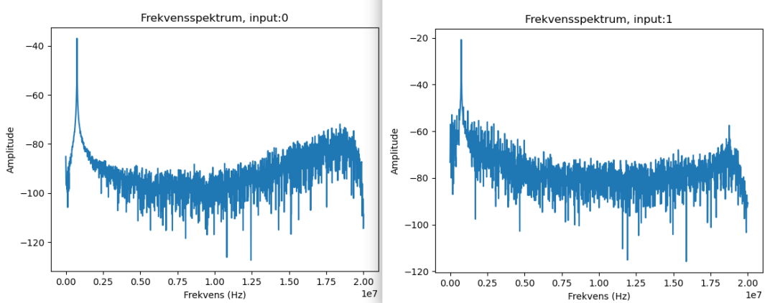

Med groundplane:
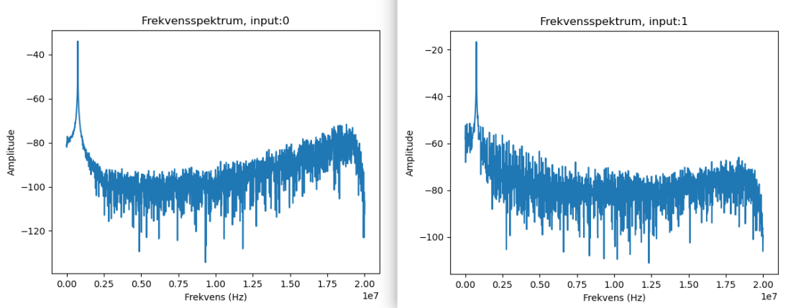

0 grader:
bf: -0.18582086716404797
bf: 1.207265633906291
bf: 0.0969004522021052
bf: 2.515991741294789
bf: 2.4886316136141904
bf: 0.7900236867772015
bf: 2.6527923796977704
bf: -1.0362648359025775
bf: 1.7521881768781578
bf: -5.899527531128487
bf: 0.5232624418913859
bf: 0.3180614842869271

-18:
bf: 14.178246165148769
bf: 14.613728197398254
bf: 17.771542933867014
bf: 19.372110403181882
bf: 22.910686916538943
bf: 16.49929699671932
bf: 17.06245962481158
bf: 13.318682153850048
bf: 20.498435659366407
bf: 16.937059039608847
bf: 16.07977503895017
bf: 14.09844579274703

+20 grader:
bf: -19.41087058406273
bf: -25.863300695403247
bf: -12.89688018544087
bf: -8.984381927115669
bf: -17.58002204010286
bf: -21.702281277312625
bf: -25.113177194826907
bf: -16.729578071364333
bf: -13.051920908964245
bf: -8.143058000937343
bf: -16.32829619871559
bf: -20.678556499930338
bf: -25.074417013946075
bf: -13.074721015364743
bf: -7.862616692211234
bf: -17.19470024193446
bf: -20.75607686169202
bf: -21.549520564429304
bf: -16.786578337365576
bf: -12.00995604646155
bf: -7.700735936767711

Test i lyddødt rum

Uden signal:
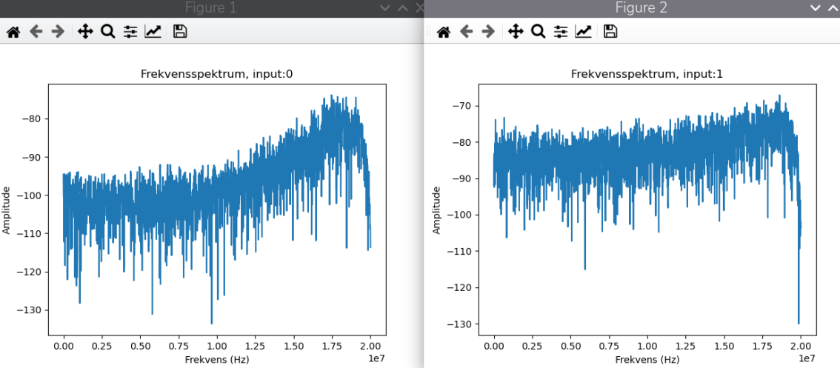

Med signal:
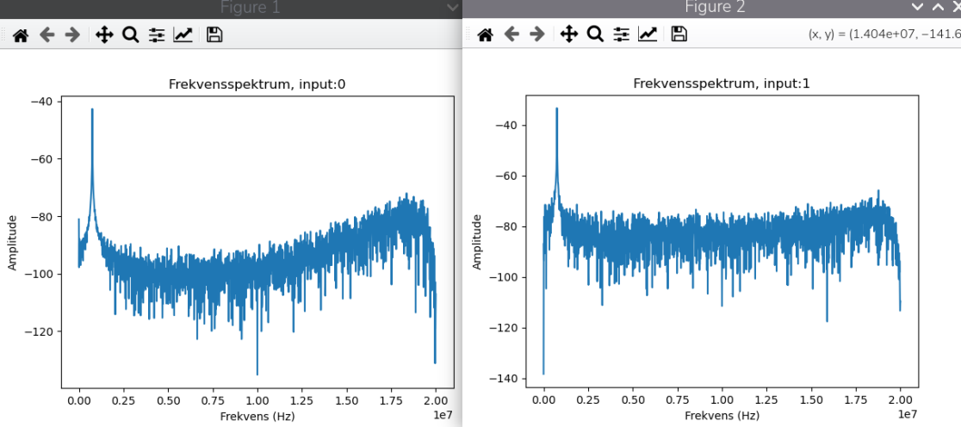
BF virkede

20 dB gain på begge kanaler:

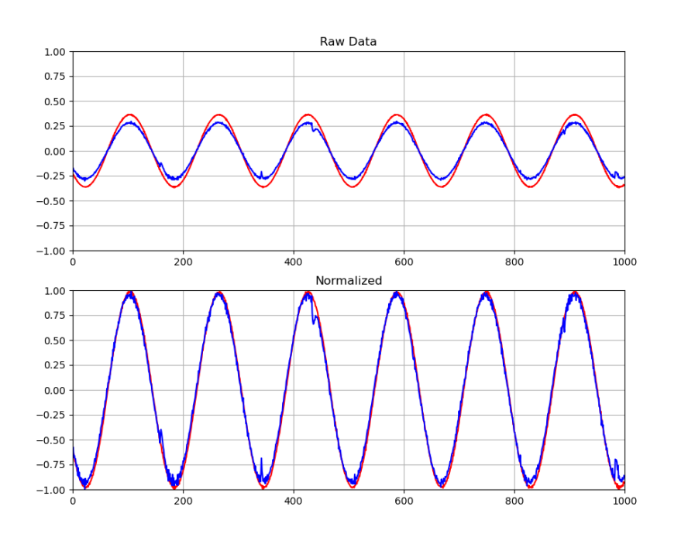
BF stoppede med at virke ved omkring -40dBm @1.4 meter

